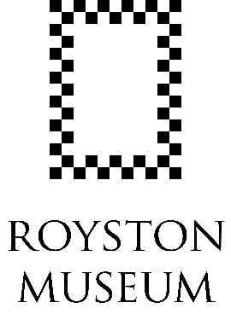

Young Artist Open Exhibition Submission Form

Calling all young artists! We’re looking for local young people to take part in our first Young Artist Open Exhibition. The theme for our exhibition is “Our World”, and will be a celebration of our planet and how we can work together to protect it.

The deadline to return your submission form and photo of your artwork is Friday 30 May.

Young artist name: |  |  | Age:
Parent/ carer name:
Address:
Postcode: |  | Telephone number:
Parent/ carer email:

Artwork title:
Medium:
Size: | Height: Width:

Tell us about your artwork (up to 100 words)
You might want to think about the following questions:
- What is your work about?
- What inspired you?
- How did you create it?
Young Artist Open Exhibition Information

We’re looking for local young people to take part in our first Young Artist Open Exhibition. The exhibition is open to everyone under 18, so whether you’re 5 or 15, this is your opportunity to have your artwork displayed at the Museum.

The theme for our exhibition is “Our World”. The exhibition will be a celebration of our planet and how we can work together to protect it. Your artwork could be of your favourite things in nature, made from recycled materials or a call to action to stop climate change, the possibilities are endless. The exhibition will open on Thursday 12 June as part of our events for Great Big Green Week, and will run through to mid-September.

To take part, submit an application form and a digital photograph of your artwork to hello@roystonmuseum.org.uk by Friday 30 May.

Submission Criteria:
- The exhibition is open to all young people under the age of 18 who live in Royston and the surrounding villages.
- You are able to submit 1 piece of art, which meets the following criteria:
  - Artwork must be 2D
  - Artwork can be in any medium.
  - Artwork must be no-larger than A3 in size.
  - Artwork must be framed, apart from box-framed canvases.
  - Clearly label your artwork with your name and its title on the back.

In the event that we receive more submissions than we have space to display, then we will need to make the difficult decision not to display some artwork. We will let you know via email if this is the case.

We will take every care with the artwork submitted for the exhibition, however Royston Museum will not be responsible for any loss or damage.

Key Dates:
- Submission opens: Monday 7 April
- Submission deadline: Friday 30 May
- Delivery of work: Saturday 7 and Sunday 8 June, 10am to 4pm
- Preview event for young artists and parents: Wednesday 11 June, 4pm to 5pm
- Exhibition dates: Thursday 12 June until Sunday 7 September
- Collection of work: Saturday 13 and Sunday 14 September, 10am to 4pm

Signed: |  | Date:

